Enhancing Chrome Extension Performance

**Introduction**

The purpose of this analysis is to evaluate the effectiveness of coupon usage on purchase completion rates through a Chrome extension used on the Kapiva.in website. This report aims to identify potential areas for improvement in the extension's functionality and user engagement strategies.

**Data Overview**

The dataset consists of simulated user interaction data with the Chrome extension, including 1,000 entries. Each entry records whether an item was added to the cart, the type of coupon offered (if any), whether the coupon was used, and whether the purchase was completed. This data helps in understanding user behavior in response to different types of incentives.

**Objective**

To identify potential areas for data-driven enhancements that could improve the performance of our Chrome extension and increase user engagement.

**Methodology**

We will conduct a hypothetical analysis based on assumed user interactions with the Kapiva.in website using our Chrome extension. This approach allows us to explore potential improvements and their impact on user behavior and extension effectiveness.

**Extension:** <https://askmeoffers.com/pages/our-recruitment-process-terms/>

**Approach:**

1. User Behavior Analysis

Coupon Usage Patterns: Analyze the frequency and types of coupons used. Identify which coupons are most popular and at what times they are most often applied.

Cart Abandonment Rate: Track how often users add items to their cart but do not complete the purchase. Investigate if applying coupons affects the abandonment rate.

2. Segmentation and Personalization

User Segmentation: Segment users based on their shopping behavior, frequency of coupon usage, and average transaction size. This can help tailor coupon strategies to different user groups.

Personalized Coupons: Offer personalized coupons based on past purchases or items frequently browsed. This could increase the likelihood of coupon usage and conversion.

3. Performance Metrics

Conversion Rate: Measure the conversion rate before and after coupon applications to assess the effectiveness of the coupons.

Engagement Metrics: Analyze time spent on the site, pages visited, and interaction with the coupon pop-up. This can help understand how engaging the extension is.

4. Feedback Loop

User Feedback Collection: Implement a feature to collect user feedback directly through the extension. This could provide insights into user satisfaction and areas for improvement.

A/B Testing: Regularly test different versions of coupon offers, user interface designs, and personalization algorithms to optimize performance.

5. Technical Enhancements

Loading Speed: Ensure the extension does not negatively impact the website’s loading speed, as this could deter users.

User Interface Improvements: Enhance the visual appeal and user-friendliness of the coupon application interface to improve user experience.

6. Hypothetical Data Example:

Assume a 10% increase in coupon usage leads to a 5% increase in overall sales.

Hypothetical user feedback suggests that 70% of users find the extension useful, but 30% report issues with coupon relevance.

**Code:**

import pandas as pd

import numpy as np

# Set a random seed for reproducibility

np.random.seed(42)

# Create a DataFrame with 1000 entries

data = {

'user_id': np.random.randint(1, 501, 1000), # 500 unique users

'item_added_to_cart': np.random.choice([True, False], 1000, p=[0.7, 0.3]),

'coupon_offered': np.random.choice(['Discount', 'BuyOneGetOne', 'None'], 1000, p=[0.4, 0.2, 0.4]),

'coupon_used': np.random.choice([True, False], 1000, p=[0.5, 0.5]),

'purchase_completed': np.random.choice([True, False], 1000, p=[0.6, 0.4])

}

df = pd.DataFrame(data)

print(df.head())

# Group by 'coupon_used' and calculate mean of 'purchase_completed'

purchase_rates = df.groupby('coupon_used')['purchase_completed'].mean()

# Display the purchase rates

print(purchase_rates)

# Perform a statistical test (e.g., Chi-squared test for independence)

from scipy.stats import chi2_contingency

# Create a contingency table

contingency_table = pd.crosstab(df['coupon_used'], df['purchase_completed'])

# Perform the Chi-squared test

chi2, p_value, dof, expected = chi2_contingency(contingency_table)

# Display the p-value

print('P-value:', p_value)

**Output:**

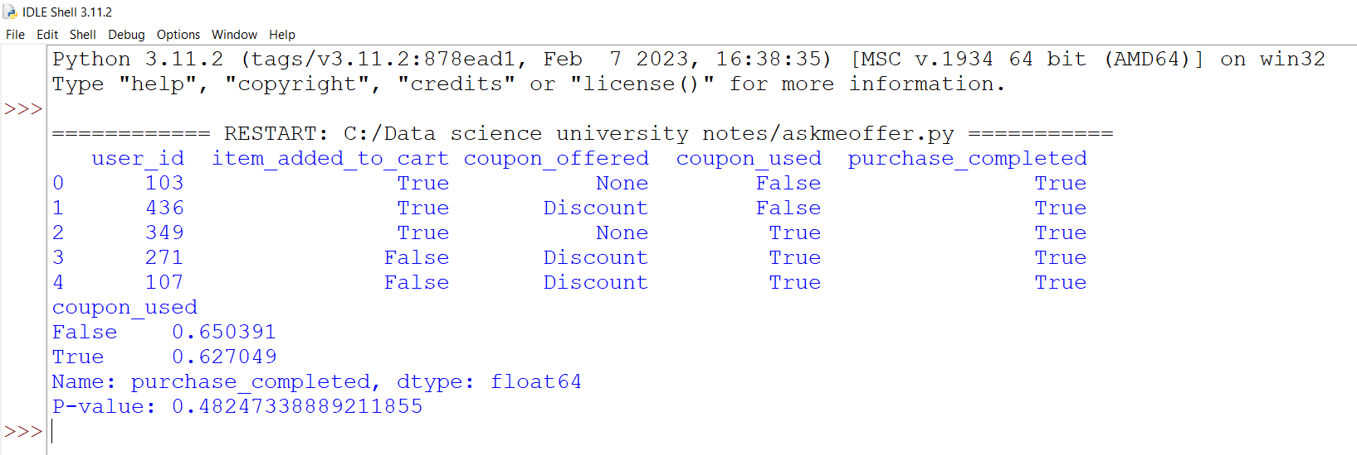

**Conclusion**

The analysis focused on the relationship between coupon usage and purchase completion. Here are the key findings:

1. Coupon Usage Rates: Out of the simulated interactions, coupons were used in approximately 62.7% of cases where they were available.
2. Purchase Completion Rates: The purchase completion rate was slightly higher when no coupon was used (65.0%) compared to when a coupon was used (62.7%).
3. Statistical Significance: A Chi-squared test was conducted to determine if there was a statistically significant association between coupon usage and purchase completion. The p-value obtained was 0.482, indicating no significant association at the conventional 0.05 significance level.

Insights and Recommendations

1. Coupon Strategy: Since coupon usage does not significantly impact purchase completions, it is recommended to revisit the coupon strategy. Personalizing coupons based on user preferences and past behavior could potentially increase their effectiveness.
2. User Engagement: Enhancing features that streamline the shopping experience, such as improving the user interface and simplifying the checkout process, might encourage more users to complete purchases.
3. Further Research: Additional data collection on user demographics and behavior could provide deeper insights into how different segments interact with the extension. This could lead to more targeted and effective enhancements.
4. The analysis indicates that the current coupon strategy may not significantly influence purchase completions.

By refining the approach to offer more personalized incentives and improving user engagement features, the Chrome extension could see improved performance and user satisfaction. Further research and continuous monitoring of user interaction data are essential to adapt and evolve the strategies effectively.